**ISSUE FIVE: 26th April 2020**

SOUTH COAST PRESBYTERIAN CHURCH

*Ordinary people* “continually praising “*an extraordinary God*

## See the source image

Many recipients of this newsletter may already know of the sad news that our dear sister and longtime member of the SCPC, Joan Boyle, was called home to be with her Lord on 25 April. We can be comforted that she is where she wanted to be, with her dear Les and her God.

Anzac Day this year saw us honour our servicemen and women in a very different way. Australians showed their spirit during a crisis as they have done many times over the last couple of centuries. Throughout the country Australian came together to “light up the dawn” as they stood at the end of their driveways to mark the landing at Gallipoli of the ANZAC soldiers, and took a moment to reflect on the sacrifices made by our service men and women during wars and conflicts since that day in April 1915.

The human suffering and death toll from wars have been horrific, an estimated 61,522 Australian lost their lives in the First World War, 39,655 in the Second World War, 340 during the Korean War, 521 during the Vietnam War and 45 in Afghanistan up to the present.

Just like the wars fought by not only Australians in the past but the entire world the Covid19 pandemic is claiming lives and causing suffering throughout the world. The death toll continues to rise throughout the world as we are “at war “with this virus, to date there have been 197, 246 deaths from a total of close to 3 million affected.

This virus is a different war that we fight today, and like all wars can feel like “Hell” for many who have lost loved ones or are suffering from isolation. Is this evil at work and how should we as Christians respond?

Although primarily about war II found many similarities in this article on how we deal our present situation as we are “riding out to conquer and fight”.

(*The full article is included as that is a condition of the copyright*.)

**What is the Christian perspective on war?**

**Phillip Jensen**

It was one of the first men to use total war, American Civil War General William Sherman, who used to say, "War is hell!" He was both right and wrong.

It is hellish in its horror and destruction: the unleashing of the forces of evil.

It is hellish in its suffering. The four horsemen of [Revelation 6](https://www.biblegateway.com/passage/?search=Revelation+6%3A1-6%3A17) riding out to conquer and fight, to impoverish and to kill, are the realistic images of war. For with war come not only conquest and hostility, but also economic disaster, illness, and death.

It is also hellish because it is the consequence of and judgment upon sin. It is the Lamb who opens the seals that release the four horsemen—the Lamb who died to take away the sin of the world and has risen to rule and put into effect the plans and purposes of God. It is the Lamb, Jesus, who sends the four horsemen into the world as part of the judgment of God upon sinful humanity.

But war is not hell. Like all human self-willed chaos, it is only the foretaste of hell. The four riders of the Book of Revelation are only a beginning and warning of the judgment to come. In any event, war raises a multitude of questions. Where does war fit into God's plans? Is God on our side? How does war look from God's perspective? What should Christians be praying for, hoping for, and expecting to happen? Fortunately, the Scripture in general, and particularly the sixth chapter of Revelation—a text often ignored and feared because of its apocalyptic content—provides guidance in times such as these.

Five Views

Let me begin by briefly outlining five different attitudes to war, because God's Word has something to say to each.

First there are the doves, the pacifists who are opposed to all war and all violence. We all have sympathy for this position. The biblical image of heaven, after all, is of peace and harmony, where people "will beat their swords into plowshares and their spears into pruning hooks. Nation will not take up sword against nation, nor will they train for war anymore" ([Isa. 2:4](https://www.biblegateway.com/passage/?search=Isaiah+2%3A4)). The Prince of Peace will usher in the time when "the wolf will live with the lamb" ([Isa. 11:6](https://www.biblegateway.com/passage/?search=Isaiah+11%3A6)). That, however, is exactly what I believe is wrong with the pacifists' position: It is the wrong timing. We are not in the Garden of Eden, nor yet in the heavenly city. Now is not the time for world peace. We are in the fallen world of human sinfulness, where evil people do dastardly things and where God has given governments authority to administer justice with the sword ([Rom. 13:1](https://www.biblegateway.com/passage/?search=Romans+13%3A1); [1 Pet. 2:13](https://www.biblegateway.com/passage/?search=1%20Peter+2%3A12)). Pacifism is a godly mistake in that it fails to take seriously the sinfulness of humans, for monsters do exist and do need stopping. We are all capable of doing real harm to our neighbour and need the constraint of law and order and of good government.

The second attitude is the opposite of the dove: the hawk. By this I mean the person who is always looking for a fight, for controversy and the use of force to get his way. While one can be sympathetic with the godly mistake of the dove, there is little or no sympathy for the man of violence. The Scriptures say, "The Lord … hates the wicked and the one who loves violence" ([Ps. 11:5](https://www.biblegateway.com/passage/?search=Psalm+11%3A5), ESV), and "human anger does not produce the righteousness that God desires" ([James 1:20](https://www.biblegateway.com/passage/?search=James+1%3A20)). So we are warned: "Do not envy the violent or choose any of their ways. For the Lord detests the perverse but takes the upright into his confidence" ([Prov. 3:31-32](https://www.biblegateway.com/passage/?search=Proverbs+3%3A31-3%3A32)). Nowhere in the Bible do those who love violence get God's approval. Those who are pleased, thrilled, and excited about war should look to themselves and repent, for they are out of step with God.

The third and fourth attitudes are neither pacifist nor militaristic. The difference between them is timing.  
In Ecclesiastes we read the striking verse, "a time to love and a time to hate, a time for war and a time for peace" ([Ecc. 3:8](https://www.biblegateway.com/passage/?search=Ecclesiastes+3%3A8" \o "view Scripture passage at BibleGateway.com" \t "_blank)). There is a time for governments to take action, to step into the affairs of the world with punitive force, be it by the police, the judiciary, or the military. There is "a time for war."  
But when is the time? Was Neville Chamberlain right in his timing, or too slow to go to war? Was Winston Churchill right or too precipitous? It is a matter of human judgment of the pragmatics and strategy of war. We are not God, and we do not know what to do. "Not yet," then, is the third position.

Many believe their government acts too quickly and condemn it as immoral and genocidal. But the Bible says we must nonetheless respect those who are appointed over us in government. The first-century Christians were called upon to respect and obey the tyrannical and persecuting Roman government of their day as being appointed by God. It is no less incumbent on us to respect our leaders ([Rom. 13:1](https://www.biblegateway.com/passage/?search=Romans+13%3A1); [1 Pet. 2:13](https://www.biblegateway.com/passage/?search=1%20Peter+2%3A13)). And we must not attack the servicemen and servicewomen who, obedient to the duly elected government of the day, are willing to lay down their lives to protect our freedom, including our freedom to dissent from government opinion.

The fourth attitude is that of "at last" we have had to act. Those who hold this position must remember that God is not on one side in war. He is not utterly disinterested, but neither does he identify completely with one side or the other. Wars are ours, not his. Our wars cannot be fought in the name of God. Furthermore, it is worth reminding ourselves to keep listening to others and weighing the costs and benefits of war. For as the Bible teaches, "Surely you need guidance to wage war, and victory is won through many advisers" ([Prov. 24:6](https://www.biblegateway.com/passage/?search=Proverbs+24%3A6)). And as Jesus said, "Or suppose a king is about to go to war against another king. Won't he first sit down and consider whether he is able with ten thousand men to oppose the one coming against him with twenty thousand? If he is not able, he will send a delegation while the other is still a long way off and will ask for terms of peace." ([Luke 14:31-32](https://www.biblegateway.com/passage/?search=Luke+14%3A31-14%3A32)). In listening to advisers and weighing the options, remember the words of Oliver Cromwell to the Scots just a month before the Battle of Dunbar: "I beseech you, in the bowels of Christ, think it possible you may be mistaken."

And then the fifth and final attitude: the fence. Many of us feel ourselves unable to decide. We do not want to go to war, but we do not want to see tyranny grow. We certainly do not want weapons to proliferate and fall into the hands of terrorists, but then again, we do not know the best way to prevent that.

Those in this position may not know what to do politically, but they can always pray. Paul tells us to pray for those in government over us "that we may live peaceful and quiet lives in all godliness and holiness" ([1 Tim. 2:2](https://www.biblegateway.com/passage/?search=1%20Timothy+2%3A2)).

*—Phillip Jensen is the dean of Saint Andrews Anglican Cathedral in Sydney, Australia.*

*Adapted from " Apocalypse Again and Again" by Phillip Jensen, Christianity Today.*

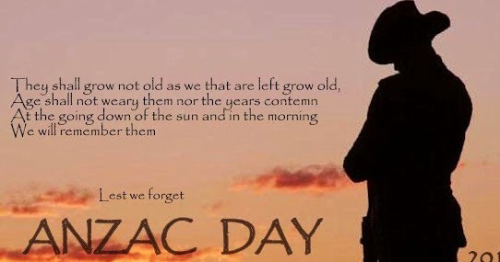

**A PRAYER OF REMEMBERANCE**  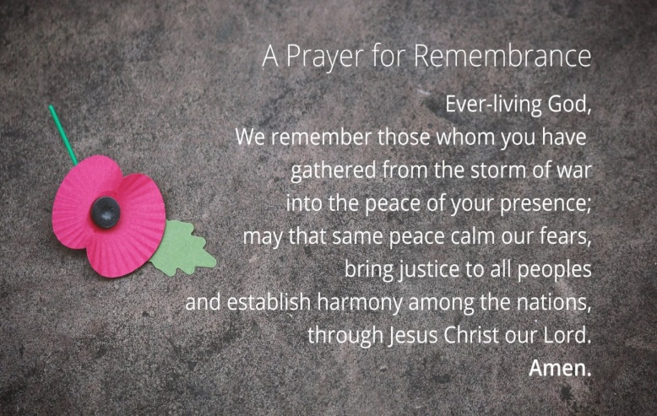

\*\*\*\*\*\*\*\*\*\*\*\*\*\*\*\*\*\*\*\*\*\*\*\*\*\*\*\*\*\*\*\*\*\*\*\*\*\*\*\*\*\*\*\*\*\*\*\*\*

A thought from Heather:



**SAFETY FIRST**

I’m sure you will have noticed that many shops you visit these days have crosses on the floor to mark your “safe” space. It occurred to me looking down the isle of the super market that the only cross we need to stand on to be saved is the cross of Christ. This cross gives us life, not just for now but for eternity.

It’s ironic that these crosses have appeared to make people feel safe and offer some protection from the virus that is taking so many lives. I have also noted that many are ignoring these crosses just like they ignore the only cross that can truly save.

**The Cross of Christ**

“Nothing in my hand I bring; simply to Thy cross I cling.”

Heather

RECIPES

BIBLE TRIVIA

1 What four fishermen became disciples of Jesus?

Answer:

2. According to the commandment five, who should you honour?

Answer:

3. What is the first one of the ten commandments?

Answer:

4.Where was Jesus born?

Answer:

5.The last book of the Bible refers to the serpent as what?

Answer:

**{Answers next week}**

**week four answers**

1.What is the third commandment?

Answer: You shall not make wrongful use of the name of your God

2. What gifts did the three wise men give Jesus?

Answer: Gold, Frankincense and Myrrh.

3.What is the accession of Christ?

Answer: His is sitting on the throne at the right hand of God,

4.What fishing village did Peter come from?

Answer: Bethsaida

5Who was the richest man in the Bible?

Answer: Solomon

The army biscuit, also known as an Anzac wafer or Anzac tile, is essentially a long shelf-life, hard tack biscuit, eaten as a substitute for bread. Unlike bread, though, the biscuits are very, very hard. Some soldiers preferred to grind them up and eat as porridge.

Father John Fahey, a Catholic padre serving on Gallipoli, was unimpressed with army biscuits. He wrote, "the man who invented the army biscuit was an unmitigated rascal. As an eatable there is little to choose between it and a seasoned jarrah board."

The popular Anzac biscuit is a traditional, eggless sweet biscuit. Ingredients include rolled oats, sugar, plain flour, coconut, butter, golden syrup or treacle, bi-carbonate of soda and boiling water.

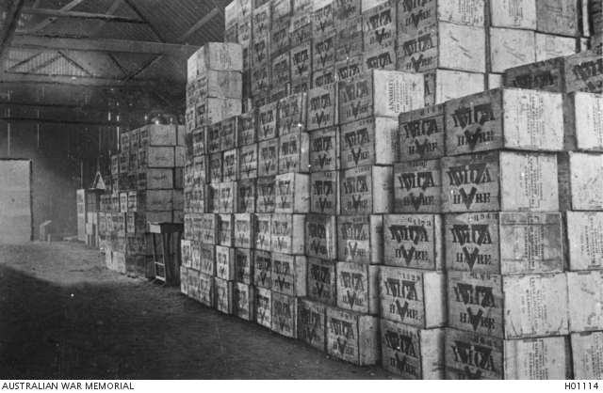

Seven days' army biscuit supply, Le Havre, France, 1918

~~~~~~~~~~~~~~~~~~~~~~~~~~~~~~~~~~~~~

I am weak but Thou art strong Jesus keep

**MUSIC**

Even when we cannot see or feel Him, the Lord never leaves our side. As we walk through each day, let us remember to call upon His name and give thanks. The beautiful lyrics of 'Nearer My God to Thee' are the perfect call to the Lord. And when you hear the story behind this amazing hymn, you will be reminded exactly why we need him every hour and second.

**The Story Behind Nearer My God To Thee**

Sarah Flower was born February 22, 1805 in Essex, England, the second daughter of Benjamin and Eliza Flowers. Sarah grew up in a home surrounded by poetry and song writing. Sarah married William Bridges Adams and moved to London where she attended the independent church of William Johnson Fox. She contributed thirteen hymns to his *Hymns and Anthems*, one of them being "*Nearer, My God to Thee*". This hymn was written to follow the

pastor’s sermon on Genesis 28:11-19, known as the story of Jacob's ladder, or Jacob's dream. Sarah wrote the hymn in a week and her sister Eliza composed the tune.

Today, the hymn is usually song to the tune "Bethany" by Lowell Mason.

[**https://youtu.be/AxT7SYH1d2c**](https://youtu.be/AxT7SYH1d2c)

**Nearer My God to Thee Lyrics**

Nearer, my God, to Thee, nearer to Thee!  
E’en though it be a cross that raiseth me,  
Still all my song shall be, nearer, my God, to Thee.

Refrain:  
Nearer, my God, to Thee, nearer to Thee!

Though like the wanderer, the sun gone down,  
Darkness be over me, my rest a stone;  
Yet in my dreams I’d be nearer, my God, to Thee.

There let the way appear, steps unto Heav’n;  
All that Thou sendest me, in mercy giv’n;  
Angels to beckon me nearer, my God, to Thee.

Then, with my waking thoughts bright with Thy praise,  
Out of my stony griefs Bethel I’ll raise;  
So by my woes to be nearer, my God, to Thee.

Or, if on joyful wing cleaving the sky,  
Sun, moon, and stars forgot, upward I’ll fly,  
Still all my song shall be, nearer, my God, to Thee.

There in my Father’s home, safe and at rest,  
There in my Savior’s love, perfectly blest;  
Age after age to be nearer, my God, to Thee.

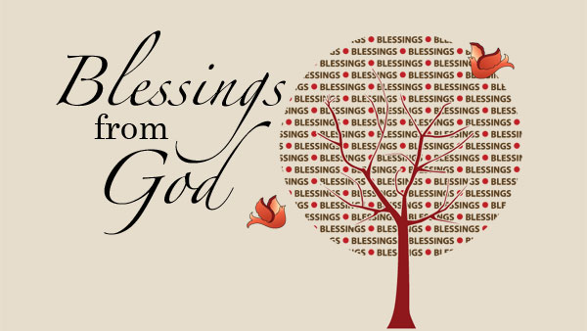d2cTo Thy kingdom's shore, to Thy shore Just a closer walk with Thee Grant it,